Society of Biology

Biologist receives top prize at SET for Britain
Released on 13 March 2012
Nicholas Love from the Healing Foundation Centre at the University of Manchester was the overall winner at SET for Britain, a prestigious competition which recognises Britain’s most promising scientists. The competition took place in the House of Commons yesterday and was attended by MPs.
Dr Love, 29, is a post-doctoral researcher studying the molecular mechanisms underlying appendage regeneration in tadpoles in order to advance research into scar-free healing. He says: “I think this win shows that what we are doing is important to people outside the field. I am really pleased to win.”
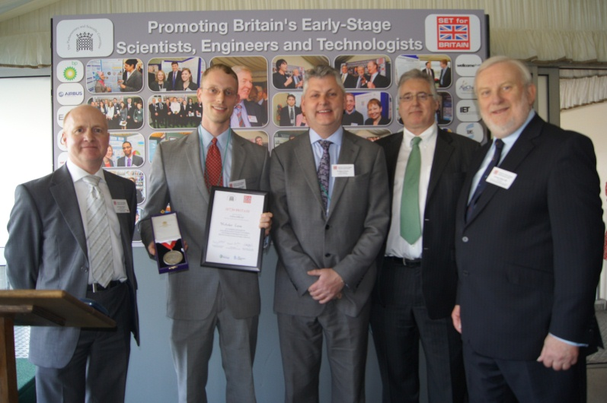
Dr Mark Downs, Chief Executive of the Society of Biology, says: “It is fantastic to see a biologist as the overall winner against some fierce competition. Dr Love is one of 56 biologists who presented their research yesterday, and this award is recognition of the importance of his work.”
The SET for BRITAIN competition is designed to support and promote British scientists, engineers and technologists in the early stages of their careers. Many will become Britain's leaders in science and technology, and their work is vital for our economy.
Young scientists presented posters about their research to MPs and expert judges at the House of Commons. There was a 2 hour judging session for the Biological Sciences included posters on topics as diverse as treatment for drug-resistant epilepsy and disease in British birds.
The Parliamentary and Scientific Committee ran the event in collaboration with the Society of Biology, The Royal Academy of Engineering, The Institute of Physics, The Royal Society of Chemistry, the Physiological Society, the Wellcome Trust and the Society of Chemical Industry.
Dr Downs was extremely impressed by the quality of the science being presented. He says: “Biosciences address some of the biggest challenges we face, from new medicines to food security. The breadth of work on display highlighted the enormous talent of young UK researchers, and it helped parliamentarians understand how science works and what the future might hold. The event also challenged biologists to make their work accessible and engage in policy issues.”
Professor Dame Nancy Rothwell is President of the Society of Biology and Vice-Chancellor University of Manchester. She says: “Dr Love’s research is part of a collaboration between the University of Manchester Faculty of Life Sciences and the Healing Foundation, set up to increase our understanding of wound healing and tissue regeneration. I was thrilled to see Dr Love’s work recognised in Parliament with this award; it is a credit to his dedication.”
Andrew Miller MP, Chairman of the Parliamentary and Scientific Committee, says: “This annual competition is an important date in the parliamentary calendar because it gives MPs an opportunity to speak to a wide range of the country’s best young researchers.
“These early career scientists are the architects of our future and SET for Britain is politicians’ best opportunity to meet them and understand their work.”
The event received financial support from BP, Airbus/EADS, The Institution of Engineering and Technology, AgChem Access, Oxford Instruments, IBMS and GE Hitachi.

